

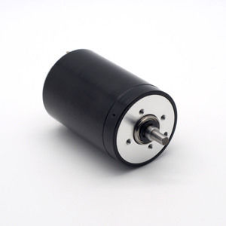

#### 35X53mm Coreless Brushed Series

**SPECIFICATIONS:**

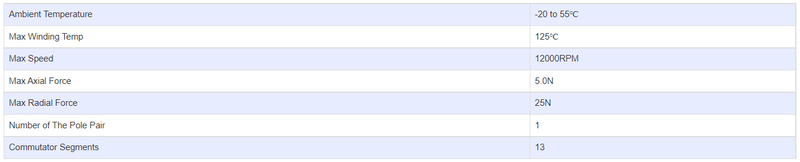

**SUBMODELS:**

*The following are common submodels for the LDO-CL3553 series.*

